**COMPILER DESIGN**

**NFA TO DFA**

**DATE:**17/02/2021 **Aim:** To perform NFA to DFA in python

**Language Used:** Python

**Procedure:**

1. Create a python file
2. Create function for taking the NFA as an input as a nested dictionary.
3. Check whether it follows all the rules of transition in Thompson's rule.
4. Display the output of the file by detecting and printing it in pandas data frame.
5. Make the table in such a way that it can display all the transitions.
6. Now create a list for subset transitions starting from the first state of keys list(a) in NFA and with all the transitions (0,1).
7. Append all the states in a list that are newly occurred in the transitions and then perform transitions in the list.
8. Display the DFA using pandas dataframe.

Code:

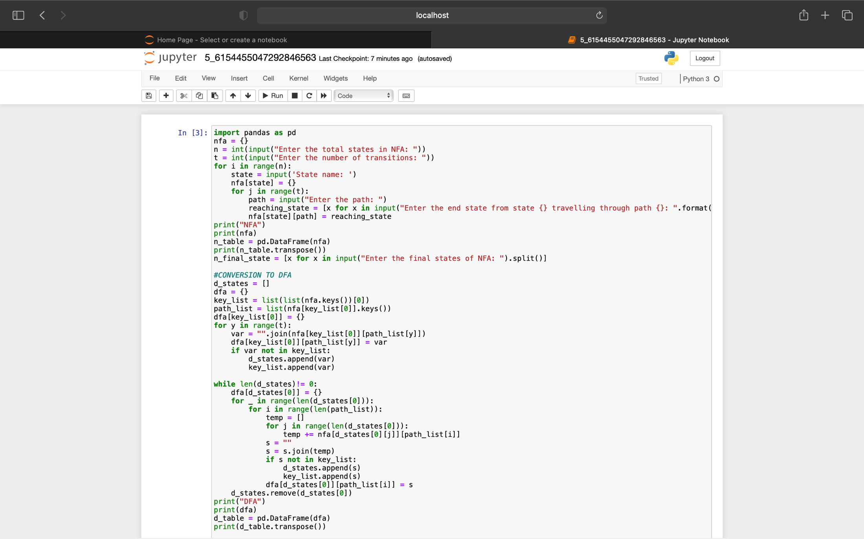

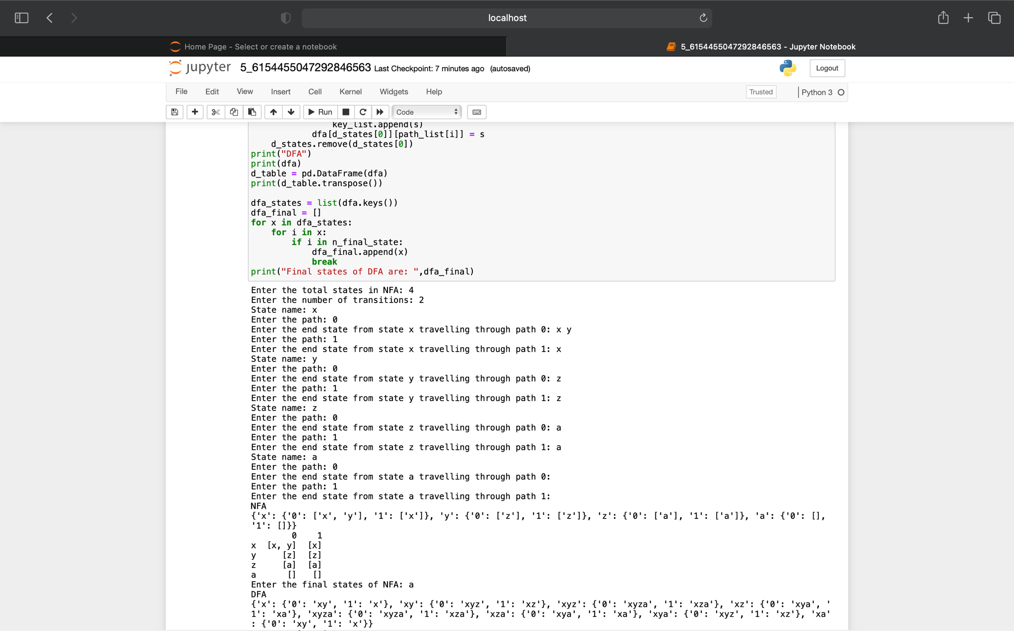

**Output:**

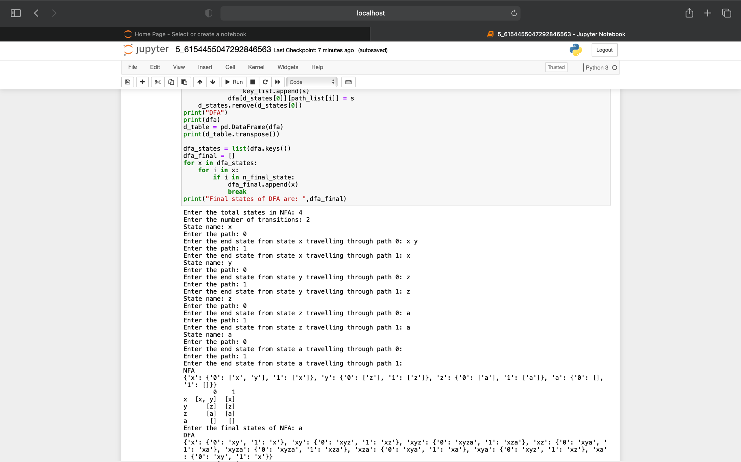

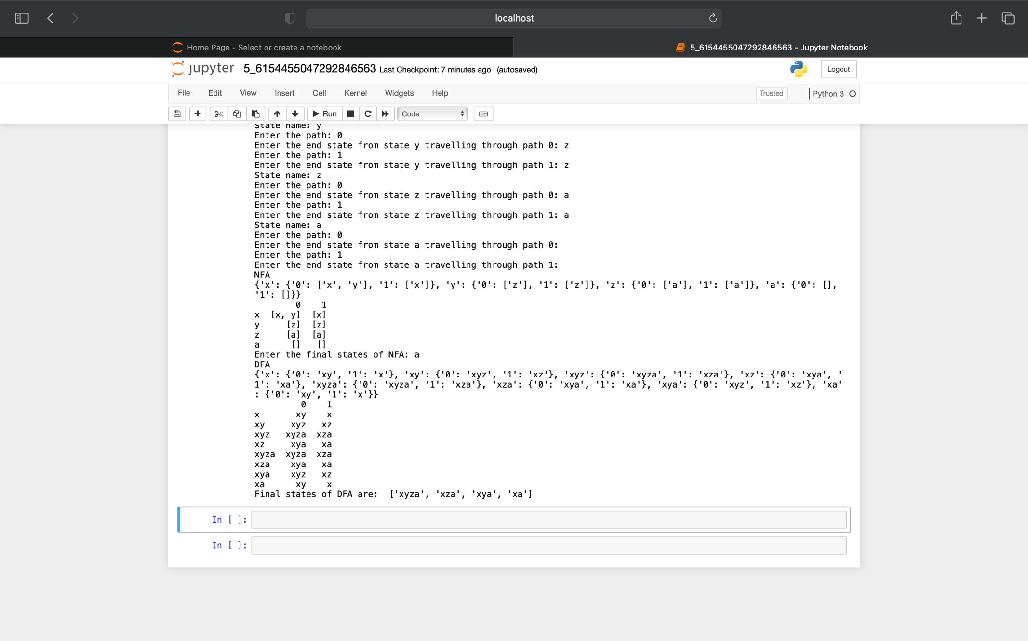

**Conclusion:** NFA to DFA convertor is being created in python.